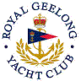 | Royal Geelong Yacht Club Inc.  Est 1859
Trophy Deed of Gift.

Trophy: | Deakin Worldly Cadet Championship Trophy
Presented by: | Deakin University
Date: | 2015
For: | TBA
Remarks / Revisions
Click here for a List of Recipients

